AP Spanish Literature and Culture
CLASE DE LA SRA. CROUCH
2023-2024
 OUR GOAL
This year we will continue building and strengthening the language skills students acquired in previous years of Spanish, particularly as they relate to literature in Spanish. For this year, our goal is that students achieve an intermediate high proficiency level (or beyond) in all the modes of communication--interpretive (listening/reading) and presentational (writing), especially, and during class, interpersonal (speaking/writing with others).
At the end of this year, students should be able to ✔ understand the main idea and key details of more complex sentences, ✔ gaining cultural competence that allows you to understand, compare practices, products and perspectives from the target cultures, and analyze and synthesize aural and written textual information within cultural, historical, and societal contexts using Spanish accurately to express your ideas.

Particularly important is this College Board page: https://apstudents.collegeboard.org/courses/ap-spanish-literature-and-culture/assessment
PROFICIENCY  Proficiency goal = Intermediate high and/or Advanced low  Click here to see Proficiency guidelines from ACTFL:  Guidelines for Proficiency |  | SECOND LANGUAGE ACQUISITION  If students acquire enough language, proficiency will follow!  How do students acquire language? Our students acquire language by listening and reading messages they understand in the language taught, which in our case is Spanish.  Therefore, in our class, we will spend a good part of our time listening, reading, and interpreting messages embedded in our classroom discussions which will be conducted mainly in Spanish. However, because at this point students have acquired language for years, we will also focus on developing listening, reading, and writing skills at the targeted proficiency level.
 THEMES AND TOPICS:
During our AP Spanish Literature and Culture Class, we will engage in analysis, conversations, and connections regarding some of the following unit topics, following College Board’s plan:

There will be a lot of reading, discussion, analysis, and making connections, through listening and speaking, and especially reading and writing, in Spanish about the literature. We will follow a College Board course outline to stay on track for preparing for the AP exam.
There will be outside of class required reading with the assumption that texts have been read or at least previewed before class discussion and analysis of the text.
Classroom Expectations:
✅ Class will be conducted mostly in Spanish. My job is to make my speech and content comprehensible. The job of the student is to always listen 👂, and signal ☝ when s/he is not understanding😵.
✅ Active participation and engagement during class are required. Let’s stay active and positive 😊 to make this class incredible!
✅ Acquiring a new language requires your full attention. Avoid side conversations. Put any distraction away including your 🎮🎧📴! Cell phones must remain inside your backpack during class.
✅ Your time during class is priceless. Be on time, be present, be here, and make it count. Limit absences and bathroom or hall passes.
✅ The use of online translators is considered plagiarism. If I suspect that you overused a dictionary or use an online translator, you can choose to receive a zero or re-do your assignment during tutoring.
What if things go wrong 😫😢?  If you receive a 0-55% for a grade,  you can redo it--reattempt it✔👍!  You need to schedule 📆 an appointment with me within the following 1 week from the date you receive your grade! |  | What if I can’t make it to class🤒🤕?  Your assignments and assessments will be in our learning system. Notes and other hand-outs can be found there also.  You will have 3 days to make up your work with an excused absence.
YOUR GRADE, as split on the AP Spanish Lit exam
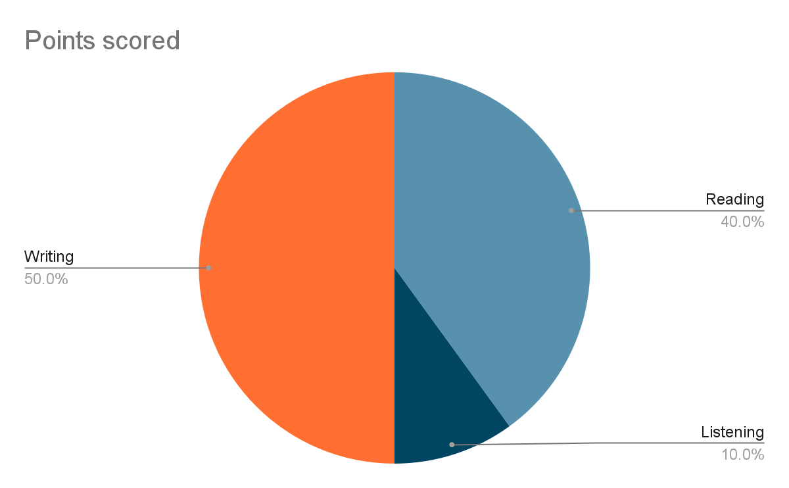
What are you going to be assessed on?  Your writing, and ability to use and make connections and analyze with the texts, will be assessed using an adjusted AP Spanish Literatand Culture rubric, for pre-AP level 4. For the listening and reading comprehension, we will use a curve if we use sample exams from AP College Board. We will use a regular scale if we´re using teacher created exams. |  | What does each category mean?  The percentages of each category fairly represent the value given to each one of the skills in the AP Spanish Literature and Culture Exam. So, listening (10%) and reading (40%) comprehension will be 50% of your overall grade.  Writing skills will represent 50% for your overall grade in the class. And, in the exam they would represent 50%, too.  Self-assessment and reflection opportunities will measure your overall consideration of your abilities. These will measure your ability in class to understand and use Spanish, to be actively engaged in class, and to carry out tasks and communicate with the teacher, to the best of your ability.
Materials | Contact Information |  | Do now
- A spiral notebook or binder with pockets  - A pen, pencil, eraser, and color markers  - Highlighters  - occasionally, you’ll be using a phone | Email:  mecrouch@madisoncity.k12.al.us  Phone: 256-216-5313  Website: https://www.madisoncity.k12.al.us/Domain/1181 |  | - Read this syllabus  - Complete your initial survey. Go to this URL https://forms.gle/gBzX695DmwGsif6K9, or scan this QR code  

