preAP/AP Spanish Language and Culture
CLASE DE LA SRA. CROUCH
2023-2024
 OUR GOAL
This year we will continue building and strengthening the language skills students acquired in previous years of Spanish. For this year, our goal is that students achieve an intermediate-mid/high proficiency level (or beyond) in all the modes of communication.
At the end of this year, students should be able to ✔ understand the main idea and key details of more complex sentences, ✔ Successfully handle uncomplicated tasks and social situations requiring an exchange of basic information, ✔ communicate and request information using connected sentences in different time frames, creating questions, and ✔ gaining cultural competence that allows them to understand, compare practices, products and perspectives from the target culture.
PROFICIENCY  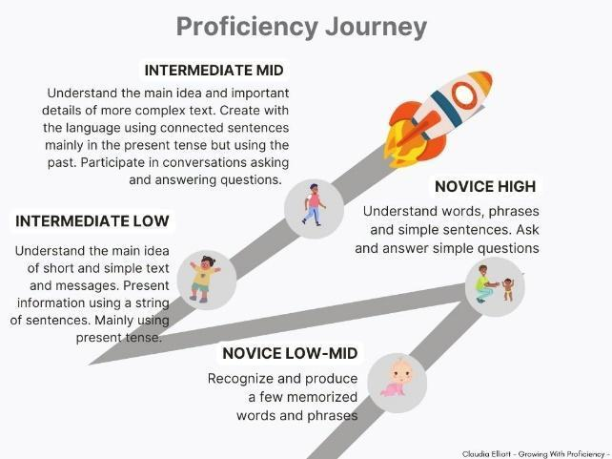  Proficiency is the ability to use language for real-world purposes to accomplish real-world linguistic tasks across a wide range of topics and settings. |  | SECOND LANGUAGE ACQUISITION  If students acquire enough language, proficiency will follow!  How do students acquire language? Our students acquire language by listening and reading messages they understand in the language taught, which in our case is Spanish.  Therefore, in our class, we will spend a good part of our time listening, reading, and interpreting messages embedded in our classroom discussions which will be conducted mainly in Spanish. However, because at this point students have acquired language for two years, we will also focus on developing speaking and writing skills at the targeted proficiency level.
 THEMES AND TOPICS:
During our AP Spanish Language and Culture Class, we will engage in conversations and stories regarding some of the following possible lesson and unit topics:
- ¿Quiénes somos? Latinoamérica y el lenguaje. Identities
- El Graffiti, ¿arte o vandalismo?. Beauty
- Las historias de los inmigrantes. Family & Global Challenges
- Destinos Latinoamericanos. Contemporary Life
- Bienvenidos: Una escuela que recibe Internet. Technology
- Trabajo voluntario: La historia del Check Andrés Experiences & Global Challenges
- Ropa, ¿moda o un ataque al medio ambiente?. La historia del desierto de Atacama Global Challenges
During the first quarter, we will read one novel as a class. Starting in the second quarter, students will spend 10 minutes reading different novels during our Free Voluntary Reading program. The goal is for each student to read 1-2 novels per month.
Classroom Expectations:
✅ Class will be conducted mostly in Spanish. My job is to make my speech and content comprehensible. The job of the student is to always listen 👂, and signal ☝ when s/he is not understanding😵.
✅ Active participation and engagement during class are required. Let’s stay active and positive 😊 to make this class incredible!
✅ Acquiring a new language requires your full attention. Avoid side conversations. Put any distraction away including your 🎮🎧📴! Cell phones must remain inside your backpack during class.
✅ Your time during class is priceless. Be on time, be present, be here, and make it count. Limit absences and bathroom or hall passes.
✅ The use of online translators is considered plagiarism. If I suspect that you overused a dictionary or use an online translator, you can choose to receive a zero or re-do your assignment during tutoring.
What if things go wrong 😫😢?  If you receive a 0-55% for a grade,  you can redo it--reattempt it✔👍!  You need to schedule 📆 an appointment with me within the following 1 week from the date you receive your grade! |  | What if I can’t make it to class🤒🤕?  Your assignments and assessments will be in our learning system. Notes and other hand-outs can be found there also.  You will have 3 days to make up your work with an excused absence.
YOUR GRADE
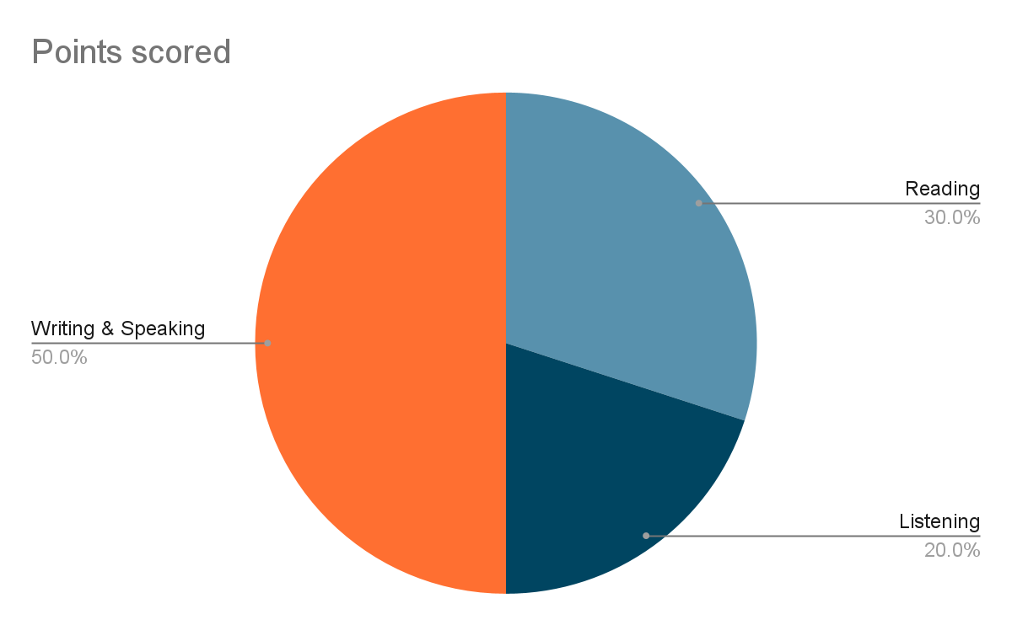
What are you going to be assessed?  The writing and oral skills will be assessed using an adjusted AP Spanish Language and Culture rubric, for pre-AP level 4. For the listening and reading comprehension, we will use a curve if we use sample exams from AP College Board. We will use a regular scale if we´re using teacher created exams. |  | What does each category mean?  The percentages of each category fairly represent the value given to each one of the skills in the (preAP) AP Spanish Language and Culture Exam. So, listening (20%) and reading (30%) comprehension will be 50% of your overall grade.  Writing and oral skills will represent 50% for your overall grade in the class. And, in the exam they would represent 50% too.  Self-assessment and reflection opportunities will measure your overall consideration of your abilities. These will measure your ability in class to listen with the intention to understand, to be actively engaged in class, and to follow our class discussions with your full attention.
Materials | Contact Information |  | Do now
- A spiral notebook or binder with pockets  - A pen, pencil, eraser, and color markers  - Highlighters  - occasionally, you’ll be using a phone | Email:  mecrouch@madisoncity.k12.al.us  Phone: 256-216-5313  Website: https://www.madisoncity.k12.al.us/Domain/1181 |  | - Read this syllabus  - Complete your initial survey. Go to this URL https://forms.gle/gBzX695DmwGsif6K9, or scan this QR code  

